Clean Code Principles - Avoid Passing Nulls and Booleans
# Source: AI Source: Provided by: [Data Path: Persons Table -> ID Column: 1, Name_En Column: Motasem Essam] -> From: [Chatgpt (GPT‑5 Mini)] on [12/9/2025]
Passing null or boolean flags as parameters often hides the meaning of the function and can lead to unexpected behavior.
Instead, use clear alternatives like method overloading, enums, or separate functions.

🔑 Why It Matters
# Source: AI Source: Provided by: [Data Path: Persons Table -> ID Column: 1, Name_En Column: Motasem Essam] -> From: [Chatgpt (GPT‑5 Mini)] on [12/9/2025]
- Makes function calls self-explanatory
- Prevents NullPointerException or logical errors
- Improves readability and maintainability
- Encourages safer and more predictable code

❌ Bad Example (Passing Null)
# Source: AI Source: Provided by: [Data Path: Persons Table -> ID Column: 1, Name_En Column: Motasem Essam] -> From: [Chatgpt (GPT‑5 Mini)] on [12/9/2025]
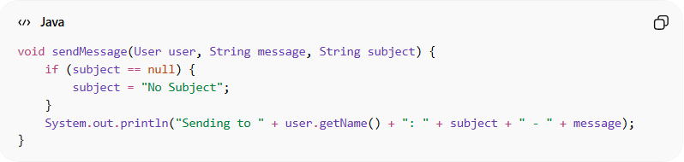
void sendMessage(User user, String message, String subject) {
if (subject == null) {
subject = "No Subject";
}
System.out.println("Sending to " + user.getName() + ": " + subject + " - " + message);
}
👉 Problems:
- Passing null is unclear
- Function must internally check for null
- Harder to understand what “null” actually means

✅ Good Example (Avoid Null)
# Source: AI Source: Provided by: [Data Path: Persons Table -> ID Column: 1, Name_En Column: Motasem Essam] -> From: [Chatgpt (GPT‑5 Mini)] on [12/9/2025]
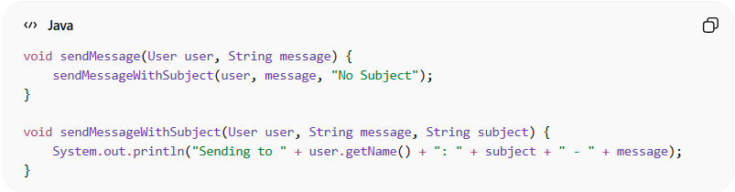
void sendMessage(User user, String message) {
sendMessageWithSubject(user, message, "No Subject");
}

void sendMessageWithSubject(User user, String message, String subject) {
System.out.println("Sending to " + user.getName() + ": " + subject + " - " + message);
}
✅ Benefits:
- Clear intent
- No null checks needed inside main function
- Easier to read and maintain

❌ Bad Example (Passing Boolean Flags)
# Source: AI Source: Provided by: [Data Path: Persons Table -> ID Column: 1, Name_En Column: Motasem Essam] -> From: [Chatgpt (GPT‑5 Mini)] on [12/9/2025]
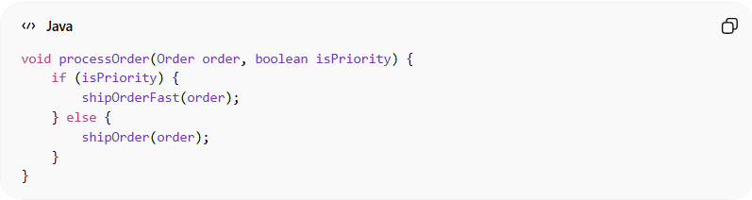
void processOrder(Order order, boolean isPriority) {
if (isPriority) {
shipOrderFast(order);
} else {
shipOrder(order);
}
}
👉 Problems:
- Hard to understand what true or false means at the call site:
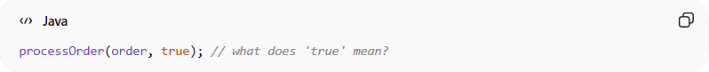
processOrder(order, true); // what does 'true' mean?

✅ Good Example (Replace Boolean with Separate Functions or Enum)
# Source: AI Source: Provided by: [Data Path: Persons Table -> ID Column: 1, Name_En Column: Motasem Essam] -> From: [Chatgpt (GPT‑5 Mini)] on [12/9/2025]
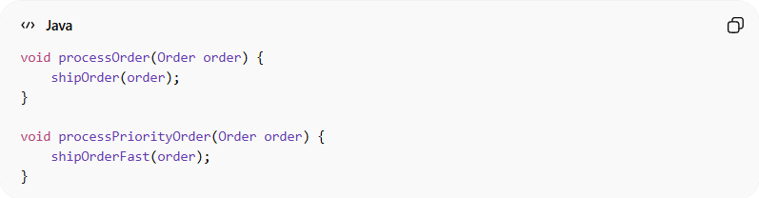
void processOrder(Order order) {
shipOrder(order);
}

void processPriorityOrder(Order order) {
shipOrderFast(order);
}
OR using an enum:
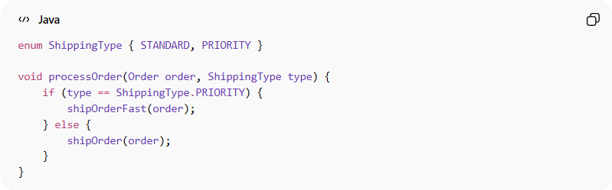
enum ShippingType { STANDARD, PRIORITY }

void processOrder(Order order, ShippingType type) {
if (type == ShippingType.PRIORITY) {
shipOrderFast(order);
} else {
shipOrder(order);
}
}
✅ Benefits:
- Clear intent
- Call site is readable:
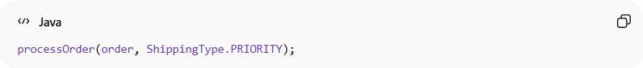
processOrder(order, ShippingType.PRIORITY);

💡 Key Idea
# Source: AI Source: Provided by: [Data Path: Persons Table -> ID Column: 1, Name_En Column: Motasem Essam] -> From: [Chatgpt (GPT‑5 Mini)] on [12/9/2025]
Avoid null and boolean flags as parameters; they obscure meaning and increase complexity.
Prefer explicit alternatives like separate functions or enums.

🚫 Common Mistakes
# Source: AI Source: Provided by: [Data Path: Persons Table -> ID Column: 1, Name_En Column: Motasem Essam] -> From: [Chatgpt (GPT‑5 Mini)] on [12/9/2025]
- Passing null to indicate optional behavior
- Using booleans to toggle behavior inside functions
- Hiding meaning of parameters behind values

🧾 Summary
# Source: AI Source: Provided by: [Data Path: Persons Table -> ID Column: 1, Name_En Column: Motasem Essam] -> From: [Chatgpt (GPT‑5 Mini)] on [12/9/2025]
Avoid passing nulls and booleans to make code safer, clearer, and easier to read.

